 | Chobham and District Riding Club
September 2021
Stay Alert and Stay Safe!
Our September newsletter includes: A review of the Show, update on training and up coming events
Bank Holiday Monday Show  I want to start by thanking our helpers from the RDA at Laris Farm, without their support, we really could not run this, or the charity show. I would like to also thank our members who volunteered their time to support in helping. Helen Edwards, Lisa Rega, Lola Rega, Kate Arnold, Abigail Arnold, Donna Still, Jess Long Celia McAllister, Alice Scott, Sue Childs and our fabulous judges, Helen Francis, Julie Johnson, Martine Cooper, Lynda Moore and Aimee FitzSimmons.  Finally, the committee who put in hours of hard work making this show such a success. Well done all. Another great achievement for CDRC!  Now to the day itself, a quieter day than the June show with some classes with no entries or very few. It is very hard to know what classes to run as numbers vary so much time to time, ideas are always welcome on what classes to try next year.  We received excellent feedback from participants on how well the show was run and how supportive everyone was. This is excellent to hear as we all know how difficult horses can be and this is the purpose of our club, to help and support each other to improve.  Based on feedback from the June show, we decided to purchase a PA system for the club, which I am pleased was a huge success and everyone could hear the announcements. |  | Images of the show will be available shortly at www.Equilens.co.uk.  Well done to all who competed. Two, highlights for me, were James Parker and Clare Webber in the pairs jumping, who although completed a lovely round, it wasn’t quite the correct course we had planned and secondly Orlando, being shown by Tabitha Bugden in the Mountain and Moorland class waving his hooves to the judge!  We hope everyone enjoyed themselves.  Members Fun day  Attached is the entry form for the members fun day.  We are offering the following lessons:  - Dressage lesson (Pairs)  - Showjumping (Group)  - Trek (Group)  You can choose to enter only 1, 2 or all 3 activites. All lessons will be held on an arena surface.  In addition to this, we will be stopping all activites over lunch to stop and celebrate the riding club being in existance for 35 wonderful years. We invite everyone to come, bring a picnic with you and celebrate this remarkable achievement together. | Please join me in welcoming our newest members -  Don’t forget to join our members only Facebook group to keep up to date on the latest news.

interested in driving?
Introduction to Driving Lessons
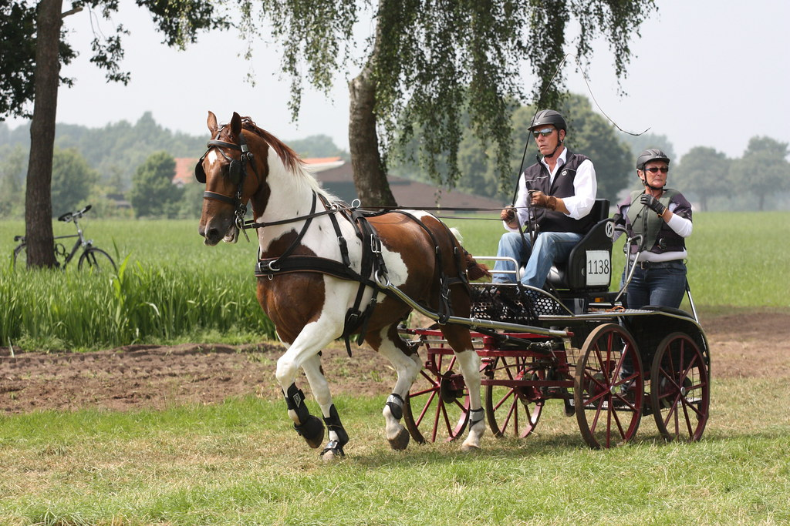
We are offering members the opportunity to learn to drive in a day out experience at Grayswood carriage driving centre in Hampshire.

You will be taught how to prepare the horse, harness up and put to the vehicle covering all aspects of safety, horse comfort and discuss any varying methods.
you will be taught “coachman style” for holding the reins so before you get to the real horse we show you how to steer and stop using our model “Woody”.
When you are ready, we have a large all-weather arena where you can safely take the reins with one their experienced horses. We start with simple steering and brakes then progress into trot
As the session draws to a close you will be shown how to unhitch and unharness your horse and attend to their
needs.

We are yet to confirm a date, but if you are interested please let us know so we can facilitate.
Cost - £50 per person

Upcoming events
To enter any training clinic please email us.

05 September 2021
Indoor Dressage at Merrist Wood
There is still time to enter. Visit our website or My Riding Life to enter!

11th September 2021
Showing /WHClinic with Amy FitzSimmons
The week before the sunshine tour finals, brush up on your showing skills to gain maximum points in the ring.
(This will only go ahead if we have enough participants)

18 September 2021
Polework or jumping clinic with Jade Hyatt
(specify polework or height to jump on entry)

Saturday 25 September 2021
Dressage lesson with Andrew Gould
Lesson will cost £40 per person for a 45minute shared/pair lesson

02 October 2021
Members only Fun Day and 35th Anniversary Celebration
To be held at Twelve Oaks, Windlesham

Autumn Orienteering
Date to be confirmed

Congratulations to those who competed for the club at the area Dressage at the weekend  Sophie Robertson came 10th  Elizabeth Sharpe came 9th  Sue Chinery came 15th  All in very busy classes, well done all.  CDRC Committee  Chair – Sara Green  Secretary – Amelia James  Treasurer – Nick Valvona  Membership – Claire Valvona  Teams & Training – Liz Hillier-Sinclair  Area Liaison – Caroline Shrub  Website & Communications - Paul Broadest-Dixon  Committee Member - Malcolm Hunt | Contact us:  ChobhamRC@gmail.com  WWW.Chobhamridingclub.co.uk

